L- 5 **Eigenvalues and Eigenvectors**



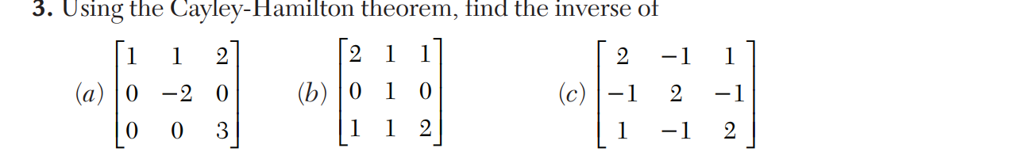

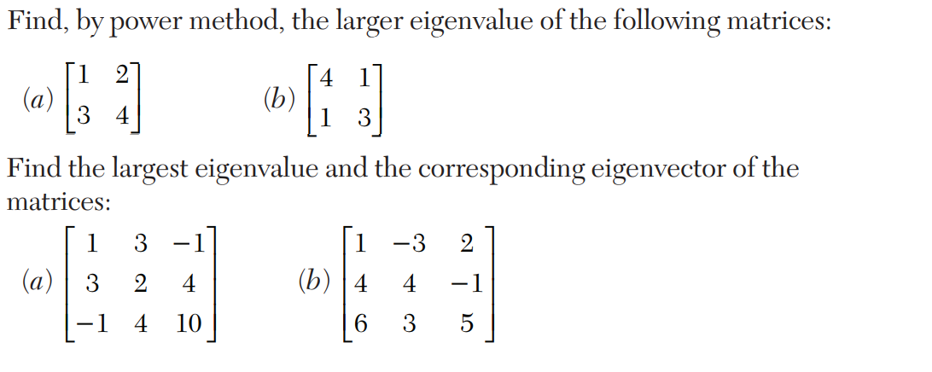

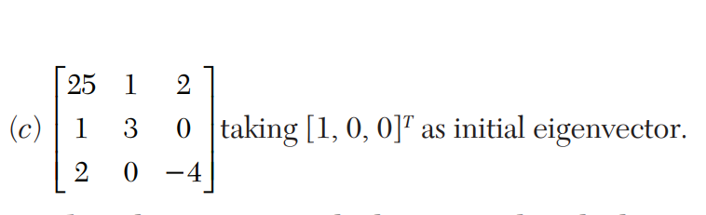

L- 6 **EMPIRICAL LAWS AND CURVE-FITTING**

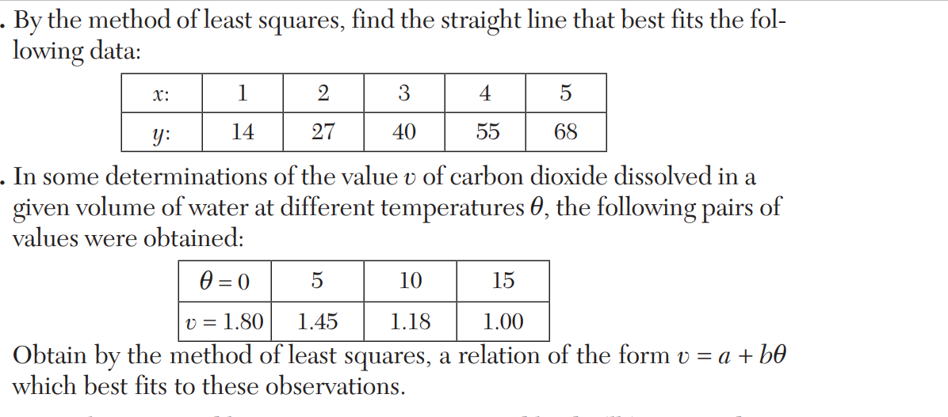

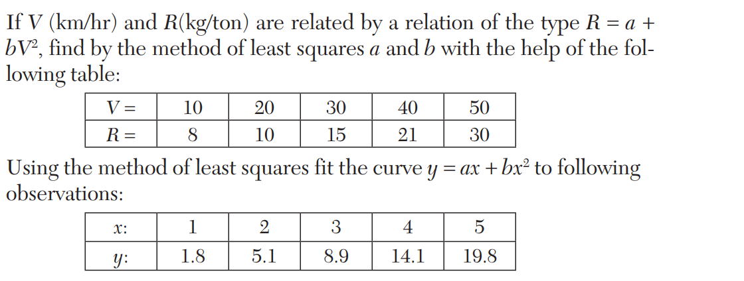

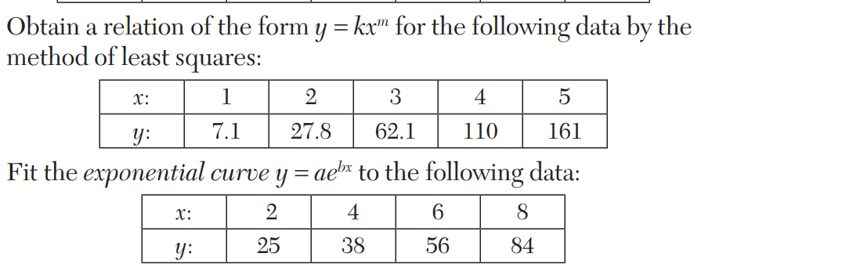

**L 7(1) FINITE DIFFERENCES**

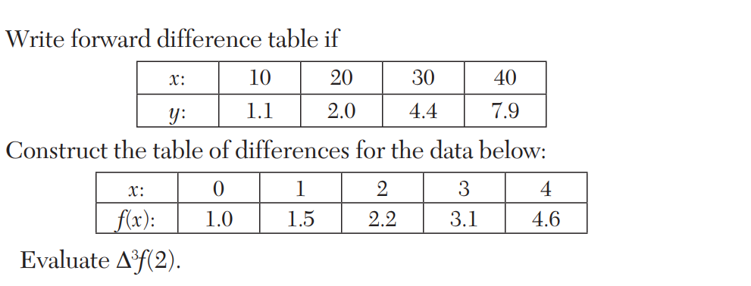

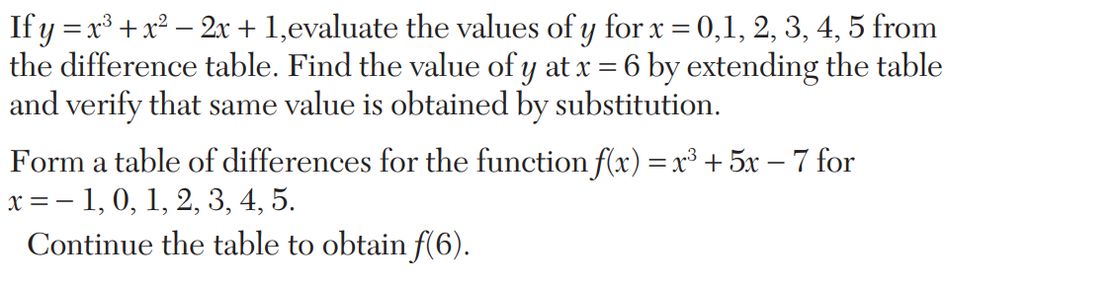

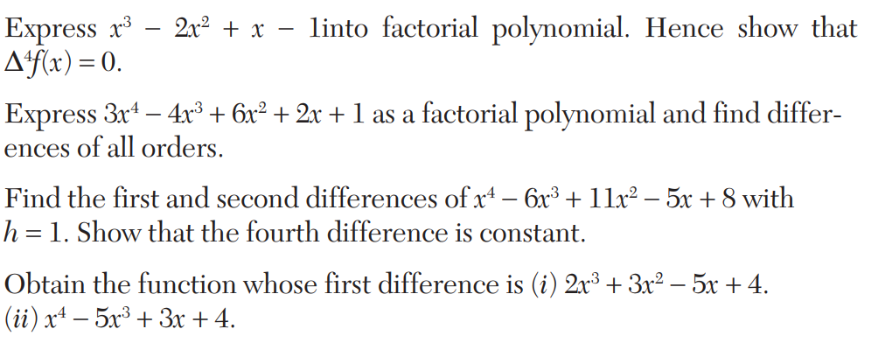

Select the correct answer or fill up the blanks in the following questions:

1

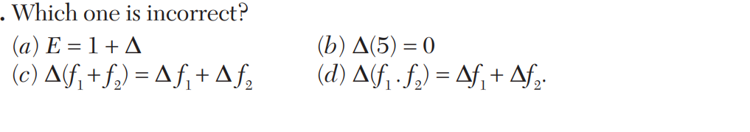

**2**

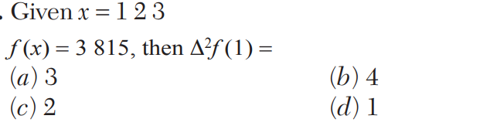

**3, 4**

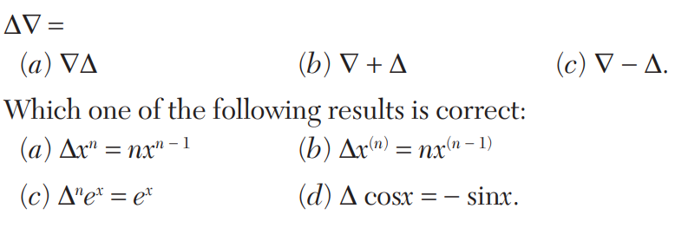

5.



**L-7 (2) INTERPOLATION**

